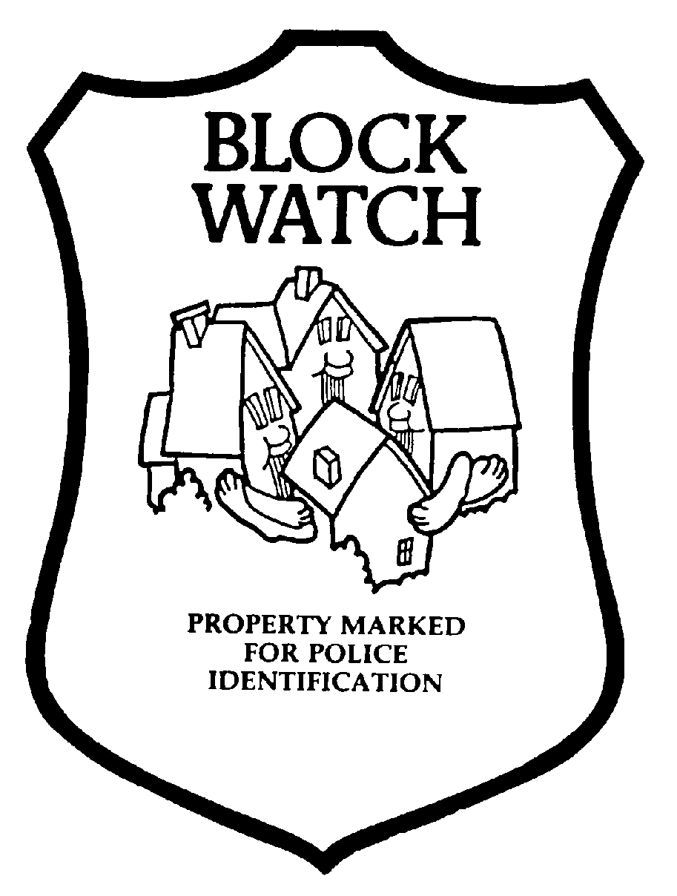
BLOCKWATCH.... Working together to prevent crime:

BLOCK CAPTAIN /CO-CAPTAIN APPLICATION FORM

Personal Information completed by applicant is collected under the authority of the
BC Freedom of Information and Protection of Privacy Act.
Last Name: | First Name: | Middle Name:
Date of Birth: | Gender: | Place of Birth:
Address: | City: White Rock | Postal Code:
Home Phone #: | Cell Phone #
E-Mail:

Previous Address (if less than 5 years).

Position applied for: Captain. Co-Captain. If Co-Captain please provide Captain’s Name: _____________________

Please provide particulars of all other household residents over 18 years of age:
Block Watch requires that every person living in the same residence as the Block Watch Captain or
Co-Captain be of good character and not be charged with or convicted of any criminal activity.
Last Name: | First Name: | Middle Name:
Date of Birth: | Gender: | Place of Birth:
Last Name: | First Name: | Middle Name:
Date of Birth: | Gender: | Place of Birth:
Last Name: | First Name: | Middle Name:
Date of Birth: | Gender: | Place of Birth:
Last Name: | First Name: | Middle Name:
Date of Birth: | Gender: | Place of Birth:
All Block Watch Captains are required to complete a Criminal Record Check.
Please attend the White Rock RCMP Detachment Front Counter 15299, Pacific Avenue, White Rock,
778-545-4800. Monday to Friday between 0830: 4:00 pm. For this service. There is no charge.
Two pieces of Government Identification are required to complete the check. A photograph must appear on at least one piece of identification and the date of birth is required on both. Upon completion, please return form to:

White Rock RCMP Block Watch.
Romy Devries - Crime Prevention Coordinator.
778-545-4778. Romy.devries@rcmp-grc.gc.ca

