**ATTACHMENT B**

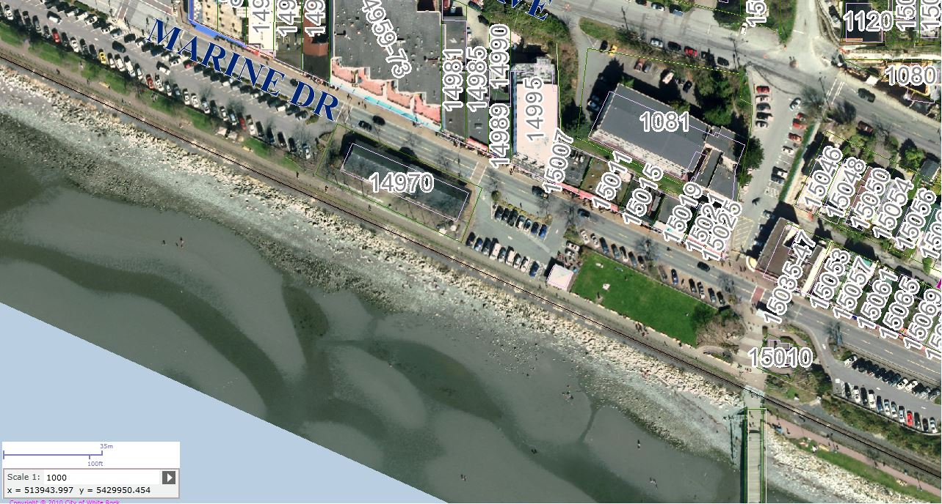

**3**

**2**

**1**

**150m**

North